**Project Design Phase-II**

**Data Flow Diagram & User Stories**

|  |  |
| --- | --- |
| Date | 27 June 2025 |
| Team ID | LTVIP2025TMID31153 |
| Project Name | Edu Tutor AI: Personalized Learning with Generative AI and LMS Integration |
| Maximum Marks | 4 Marks |

**Data Flow Diagrams:**

A Data Flow Diagram (DFD) is a traditional visual representation of the information flows within a system. A neat and clear DFD can depict the right amount of the system requirement graphically. It shows how data enters and leaves the system, what changes the information, and where data is stored.

A **Data Flow Diagram (DFD)** is a graphical tool used to model the flow of data within a system. It shows how data is **input, processed, stored, and output** in a clear and systematic way. For EduTutor AI, the DFD outlines how users interact with the system through the interface and how their data is processed by the AI model and other components.

**EduTutor-AI**

**Example:**

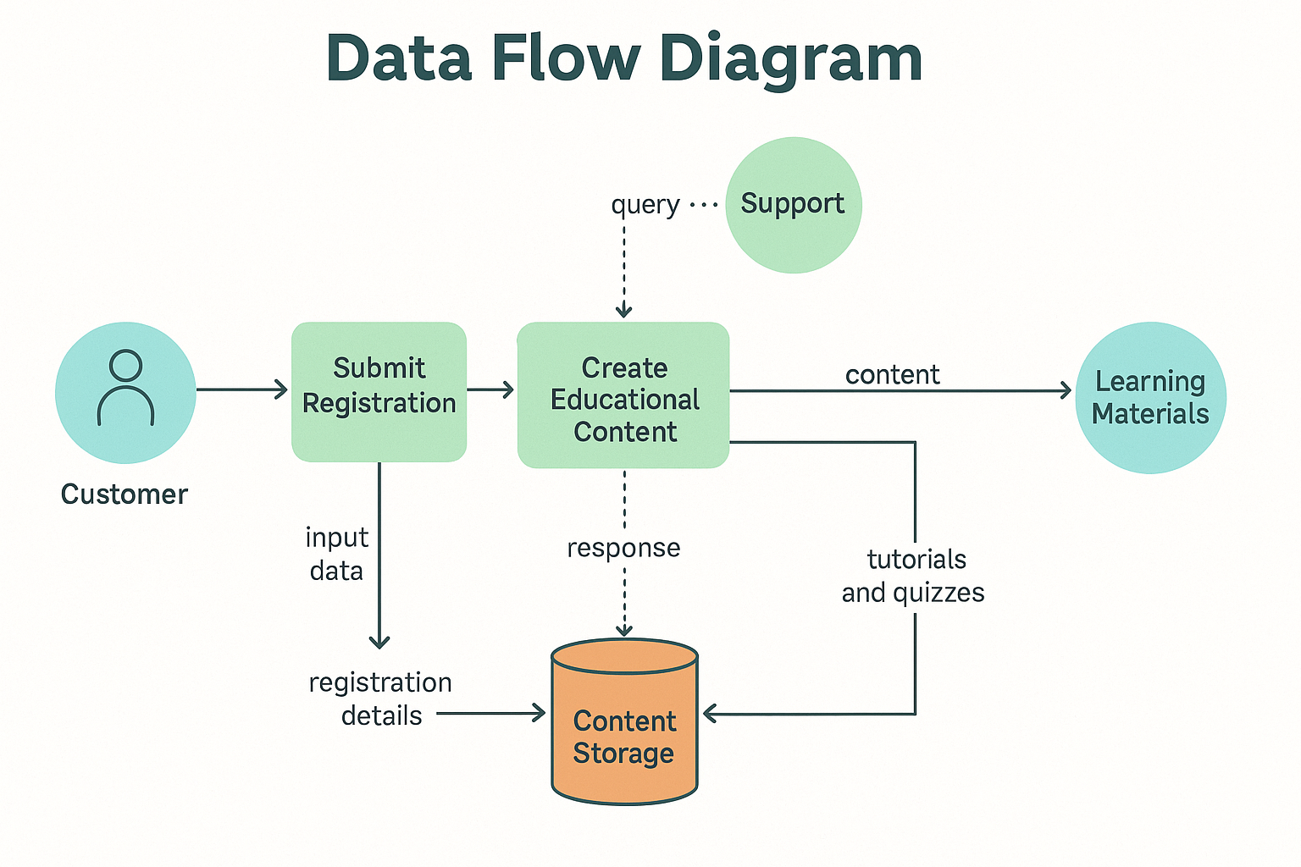

**User Stories:**

Use the below template to list all the user stories for the product.

| **User Type** | **Functional Requirement (Epic)** | **User Story Number** | **User Story / Task** | **Acceptance Criteria** | **Priority** | **Release** |
| --- | --- | --- | --- | --- | --- | --- |
| **Customer (Mobile user)** | Registration | USN-1 | As a user, I can register for the application by entering my name and password | I can access my account/dashboard | High | Sprint-1 |
|  | Login | USN-2 | As a user, I can log into the application using name & password. | Login should redirect me to the dashboard | High | Sprint-1 |
|  | Dashboard | USN-3 | As a user, I can enter a concept and get a simplified explanation. | The concept is clearly explained in an easy way | High | Sprint-1 |
|  |  | USN-4 | As a user, I can upload a PDF to generate questions for practice. | A quiz with relevant questions is generated | High | Sprint-2 |
|  |  | USN-5 | As a user, I can choose a language (English/Hindi) to learn grammar and parts of speech. | Language learning content is displayed | Medium | Sprint-2 |